Navigating between JSF Pages

Overview
In this lab you will add pages to a "Shopping" Web application, and define navigation rules to link the pages together. The following diagram shows how it will work at the end of this lab:
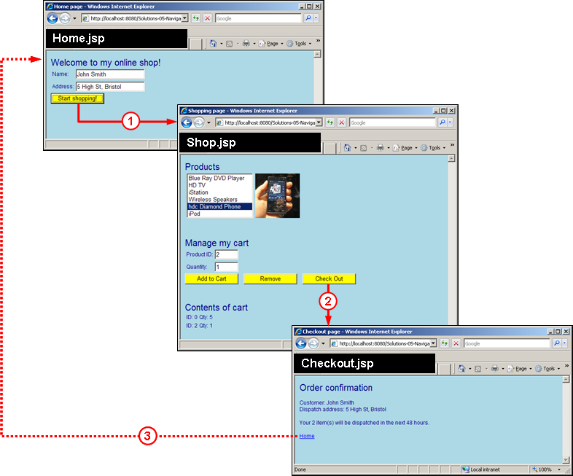

- Home.xhtml - You will implement this page from scratch. The customer enters his/her name and address, and clicks Start shopping to go to the Shop.xhtml page (see (1) on the diagram).
- Shop.xhtml - Most of this page already exists. You will enhance the page so that the Check Out button causes navigation to the Checkout.xhtml page (see (2) on the diagram).
- Checkout.xhtml -You will implement this page from scratch. The page summarizes the customer's name, address, and cart. The customer can click Home to return to Home.xhtml (see (3) on the diagram).

Student projects
We suggest you start with the StudentNavigation project for this lab, to make sure the lab instructions are in synch with the code base.

Solution project
A full solution for this lab is available in the SolutionsNavigation project. We've defined navigation rules in faces-config.xml because it keeps the Java bean classes decoupled from the actual names of web pages.

Roadmap
There are five exercises in this lab:
- Familiarization with the Web application.
- Modify cartBean to hold the customer's name and address.
- Add the home page to the application.
- Add the checkout page to the application.
- Invalidate session state after checkout.

Step 1: Familiarization with the Web application
Run the StudentNavigation project.  The Shop.jsp page should appear in the browser as shown opposite… | 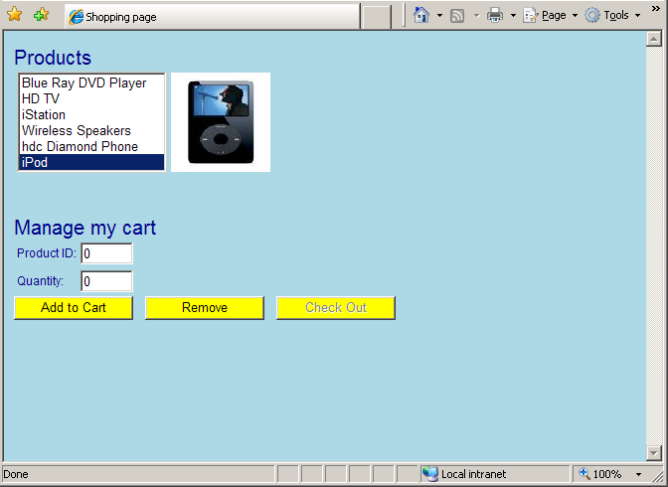

Select an item in the Products list (such as Blue Ray DVD Player). Note that the Web page displays an image for the selected item, and also displays its ID in the Product ID text box.  Enter a number in the Quantity text box, and then click Add to Cart. Notice that a Contents of cart section appears at the bottom of the page, showing the product ID and quantity.  For example, if you order 1 Blue Ray DVD Player, the page appears like so… | 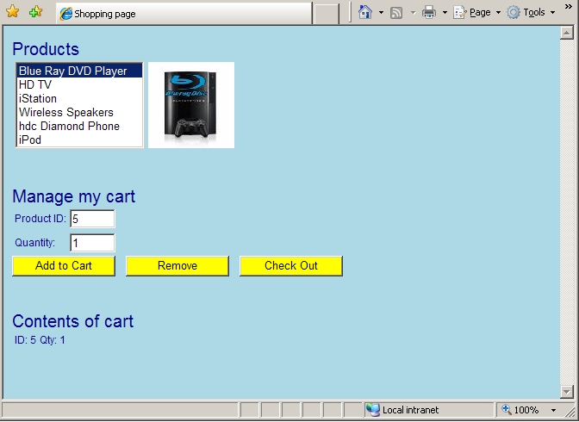

Review the code for the following classes in the mypackage source package:
- Item.java – Represents an item in the shopping cart (i.e. product ID and quantity).
- CartBean.java – Session-scope bean that manages the items in the shopping cart.
- ShopBean.java – Request-scope bean for Shop.jsp, to control the UI for the page.
- Helper.java – Helper class, used by ShopBean at the moment.

Now take a look in Shop.jsp and see how it makes use of the cartBean and shopBean beans. It also uses a bean called productsBean, which is a collection of products defined in faces-config.xml.

Step 2: Modify cartBean to hold the customer's name and address
Open CartBean.java. As just mentioned, this is a session-scope bean that holds the items in the customer's shopping cart.
Add two more fields to the class, to hold the customer's name and address (these values really do belong in this session-scope bean – the customer will enter these details in Home.jsp, and they must be retained across multiple post-backs and then redisplayed in Checkout.jsp).
Also define getters and setters for these fields.

Step 3: Add the home page to the application
Add a new JSP page named Home.jsp. Add JSF tags as appropriate, to create the following user interface (feel free to copy-and-paste bits from Shop.jsp to save you some typing ☺):
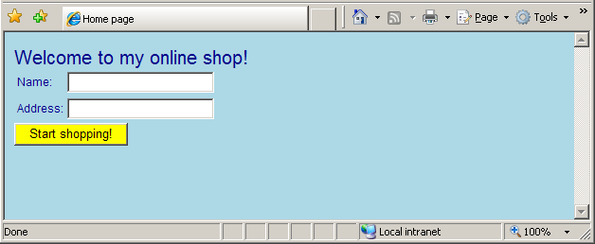
Bind the JSF tags as follows:
- Bind the Name and Address text boxes to cartBean.name and cartBean.address respectively (this ensures the customer's name and address are stored in session scope).
- Set the Start shopping button's action to the fixed string "startShopping" (this is an example of an unconditional navigation rule – when the user clicks this button, it will always have the same outcome, i.e. it will take the user to the shopping page).
- Note: There's no need for a backing bean for Home.jsp. Why not…?
Define a navigation rule for /Home.jsp, so that the startShopping outcome takes the user to the /Shop.jsp page.
Test your application by running Home.jsp. Enter your name and address and then click Start shopping. Verify that the Web application navigates to the Shop.jsp page.

Step 4: Add the checkout page to the application
Open Shop.jsp in the code editor, and locate the Check Out button. At the moment, this button has no effect. Modify this button, so that when it is clicked it causes an unconditional navigation to the checkout page, as follows:
- Set the button's action to the fixed string "checkout".
- Define a navigation rule for /Shop.jsp, so that the checkout outcome takes the user to the /Checkout.jsp page.

Now add a JSP page named Checkout.jsp to your Web application. Add JSF tags as appropriate, to create the following user interface:
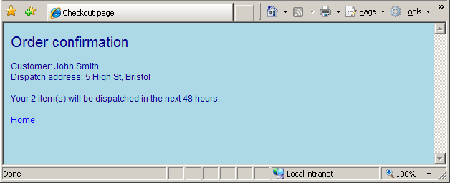
Bind the JSF tags as follows:
- To display the customer's name and address, use the cartBean.name and cartBean.address properties.
- To display the number of items to dispatch, use the cartBean.itemCount property.
- Set the Home hyperlink's action to the fixed string "home".
Define a navigation rule for /Checkout.jsp, so that the home outcome takes the user unconditionally to the /Home.jsp page.
Test your application. Verify that you can successfully navigate from Home.jsp, to Shop.jsp, to Checkout.jsp. Also verify that Checkout.jsp displays the correct details.
What happens when you click the Home hyperlink? Notice that your user name and address are redisplayed in Home.jsp, because these values are still in the (session-scope) cartBean. Furthermore, when you click Start shopping, notice Shop.jsp still displays your old shopping cart. The problem is that the HTTP session state still holds your cartBean from earlier.
You'll rectify this situation in the next step…

Step 5: Invalidate session state after checkout
Create a new request-scope bean named checkoutBean to act as the backing bean for the Checkout.jsp page. Add a method named homeHandler to handle the Home hyperlink's action (i.e. click event), and implement the method as follows:
- Call the Helper.expungeSession() method, to expunge (i.e. invalidate) session state. (Take a look at how expungeSession() is implemented in the Helper class).
This will have the desirable effect of discarding the user's cartBean. This is exactly what we want – the user has checked-out, so we don't need to hold onto their name, address, or shopping cart details any more
- Return the fixed string "home", to trigger the navigation rule that takes the user back to the home page.
In Checkout.jsp, modify the Home hyperlink's action so that it invokes the checkoutBean.homeHandler method. This is a realistic example of how JSF development tends to happen; you often start off with unconditional action strings, and then replace them with handler methods if you actually need to do something prior to navigating to a new page.
Test the application as in the previous exercise. In particular, make sure that the Home hyperlink on the checkout page does indeed clear out the user's name, address, and cart details.

Optional extension … (if time permits)
If you complete the above steps and you have a bit of time spare, here's an idea for an optional extension:
- Define a new JSP page named CheckoutBulk.jsp. Copy all of the markup from Checkout.jsp, and change a few cosmetic details. For example:
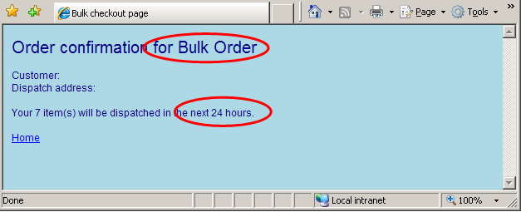
- Modify Shop.jsp (and its shopBean backing bean), so that the Check Out button navigates conditionally to one of the following pages:
    - Checkout.jsp – If the number of items in the cart is less than 5
    - CheckoutBulk.jsp – If the number of items in the cart is 5 or more
- Test the application thoroughly. One glitch that you might encounter is that the Home link on CheckoutBulk.jsp page might not work. Why would this problem occur, and how do you fix it …?

Another optional extension …
- Define a new page named AdditionalInfo.jsp, which displays some information about your shop (name, address, things like that ☺).
- Add a hyperlink (i.e. <h:commandLink> component) to each page in your application, to go to the additional info page.
- Define a ”wildcard” navigation rule that always goes to AdditionalInfo.jsp, regardless of which page you’ve come from. Hint – see the notes about from-view-id in the Chapter.
- Now here's a tricky bit… how can you let the user go back from AdditionalInfo.jsp to the page they've just come from? Here are some hints:
  - You'll need to remember the "original page" somewhere. The best way to do this is to store it in a session-scope bean, e.g. additionalInfoBean.
  - additionalInfoBean needs to deduce the current page prior to navigation. You can get this information via a combination of JSF and servlet APIs as follows:
// Get the FacesContext object.
FacesContext ctx = FacesContext.getCurrentInstance();

// Get the ExternalContext object, our gateway to HTTP info.
ExternalContext extCtx = ctx.getExternalContext();

// Get the HttpServletRequest object for the current request.
HttpServletRequest req = (HttpServletRequest)extCtx.getRequest();

// Get the request URI for the current request.
originalPage = req.getRequestURI();

  - AdditionalInfo.jsp needs to allow the user to go back to the original page. We suggest an <a> hyperlink as follows:
<a href="${additionalInfoBean.originalPage}">
Back to ${additionalInfoBean.originalPage}
</a>

There are two very interesting questions here:
- Why are we using a primitive <a> rather than a JSF <h:commandLink>?
- Why are we using JSP-style EL syntax ${…} rather than JSF-style EL syntax #{…}?

